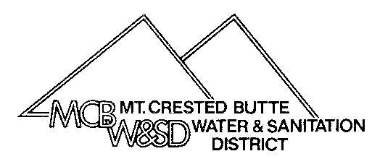
Mt. Crested Butte Water & Sanitation District
PO Box 5740
Mt. Crested Butte, CO 81225-5740
(970) 349-7575 Fax: (970) 349-0412
info@mcbwsd.com
CHANGE OF ADDRESS AND/OR OWNERSHIP
To: Mt. Crested Butte Water & Sanitation District: Date: ________________________
Please change the billing address and/or ownership information on the following account(s).

Effective Date: _____________________________________

Account Number(s): _________________________________________________

Service Address: _____________________________________________________

City: ___________________________ State: ____________ Zip: ______________

Old Mailing Address:_________________________________________________

City:___________________________ State:____________ Zip:______________

*******************************************************************************************************
New Mailing Address:___________________________________________________

City:___________________________ State:_____________ Zip:_________________

New Phone number: ________________________ Email: ______________________

Name for this new phone number: __________________________________________

Owner Information:
Old Owner Name(s): ______________________________________________________

New Owner Name(s): ______________________________________________________

Mailing address for new owner: ______________________________________________

Reason for ownership transfer: ______________________________________________

Is the new address listed above for the new owner listed here? Yes____ No_____
Signature: _________________________________

*NOTE: All ownership transfers will require a legal document showing sale or transfer.

For Office Use Only

Date: __________By: _____
Direct Pay: ____No____Yes

